Kindergartens, Geriatrics, Schools, NGOs, Immigrant centers, are currently looking for students or recent graduates of Educational /Childhood support/Social work/ Socio-Health sectors:
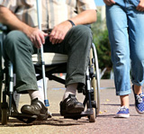 | SOURCE: Erasmus + Sevilla  ELDERLY CARE ASSISTANT  Student or recent graduate of Socio- Health Care Operator/Elderly care  Timetable: Fulltime internship. 30 – 35 hours /week. 2 days off  Location: Nursery/Elderly homes in Seville, Spain  Season: Vacancies from June 2017 – June 2018  Stay: 6 weeks minimum  UN PAID internship  Spanish B1 required
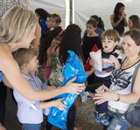 | SOURCE: Erasmus + Sevilla  SOCIAL WORK INTERNSHIPS  Student or recent graduate of Social work  Timetable: Fulltime internship. 30 – 35 hours /week. 2 days off  Location: NGOs, Immigration centres, Government Social Centres in Seville, Spain  Season: Vacancies from September 2017 – June 2018  Stay: 6 - 8 weeks minimum  DBS checks *: Criminal Records is required to work in health/children/social field  UN PAID internship  Spanish B2/ French or Arabic
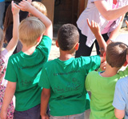 | SOURCE: Erasmus + Sevilla  NURSERY / KINDERGARTEN/SCHOOL ASSISTANTS  Student or recent graduate of Technical Support Childhood  Timetable: Fulltime internship. 30 – 35 hours /week. 2 days off  Location: Nursery/kindergartens in Seville, Spain  Season: Vacancies from September 2017 – June 2018  Stay: 4 weeks minimum  UN PAID internship  Spanish B1 or English B2. Please, click for full offer conditions
How to apply?Please, contact us for further information. email: info@oneco.org

